Siemens LADDER FB And UDT xml to Beckhoff LD1 XML Conversion Tool Design Documentation.
Use Case:
This tool allows users to convert a Siemens PLC Program Block (LADDER FB) and Siemens UDT XML file into a Beckhoff-compatible XML file in LD1 format.
Workflow:
- Select Input File: The UI provides an option to browse and select the Siemens LADDER FB XML and siemens UDT xml file.
- Convert XML: After selecting the input file, the user clicks the Convert XML button to initiate the conversion process.
- XML Conversion: The tool processes the selected Siemens XML file and converts the ladder logic into the corresponding Beckhoff LD1 XML format.
- Display Conversion Logs: The UI displays log messages in a dedicated window, showing conversion progress, status, warnings, errors, and the conversion result.
- Output Generation: Upon successful conversion, the tool generates the Beckhoff LD1 XML output file at the designated location.
Expected Outcome:
The user can easily select a Siemens LADDER FB XML and Siemens UDT xml file, convert it into Beckhoff LD1 XML format, and monitor the entire conversion process through the UI log window.
Start Application
UI Contains

UI Contains Block Conversion selection option

UI Contains UDT Conversion selection option

Select XML File
After click on Convert button process is start

After Complete the process file is generated at input xml file path with file name like InputFileName_Beckhoff.xml
Display Conversion Logs / Status.

Code Files And Description:
Program.cs: Entry point; [STAThread] Main; ApplicationConfiguration.Initialize and Application.Run(new MainForm()).
MainForm.cs: WinForms UI with two tabs, "Block conversion (FB / FC / OB)" and "UDT conversion", built with the shared CreateTab / CreateFileRow methods. Contains file selection, single and batch conversion for blocks (ConvertFile, BatchConvert) and for UDTs (ConvertUdtFile, BatchConvertUdt), the UDT file writers (WriteUdt, WriteUdtFiles), log view and progress bar.
Models.cs: Contains helper classes for BlockType, SiemensBlock, Member (with nested Children for Struct), Network, Part, Wire, ConversionReport and the UDT classes: UdtDefinition (one Beckhoff data type), SiemensUdt (Main, Nested, Warnings, All) and GeneratedFile (FileName, Xml). SiemensBlock.Udts and ConversionReport.Udts hold the UDTs created from Struct tags of a block.
SiemensParser.cs: Extract the Siemens Block XML file data (interface, CompileUnits, Parts, Wires, Access expressions).
TypeMapper.cs: Data type records and Data Type Mapper (datatype, array, string and FB-type mapping, start values).
NetworkConverter.cs: Beckhoff default XML name spaces, LdContext, Connections for network tags, Src and NetworkConverter (wire graph, emission, pin mapping, OR handling).
LayoutEngine.cs: Grid constants, Rung / RungContact / RungOutput model, ElementKind, EmittedElement, LayoutEngine.
BeckhoffGenerator.cs: Beckhoff block xml default tags assembly for: pou, interface, plain-text interface, fileHeader, project structure.
UdtGenerator.cs: Beckhoff UDT xml tag declaration and default xml file format declaration. Generate(UdtDefinition) returns the PLCopen XML text of one data type; ToFile(UdtDefinition) returns a GeneratedFile (file name + XML) for a nested UDT.
StructExtractor.cs: Lifts Struct members into separate UDTs: NewRegistry (name registry shared by a block, a UDT file or a whole batch), Lift (Struct member -> <tag>_UDT, inner types first, identical structures reuse one UDT) and SafeName (valid IEC identifier). File name taken from the class name used in the code.
LdRungOrder.cs: Orders the elements of every network so that each rung is contiguous and a ParallelBranch comes right before the element that uses it, as TwinCAT exports it.
LadderTree.cs: Series / Parallel / Element tree of one Siemens network (LadderNode, LadderTree, TreeLayout); decides where each element is placed when the coordinate layout is used.
ReportWriter.cs: New. Builds the conversion report text: Snapshot(block) records the original part names of every network before conversion; Build(block, report, snapshots) writes the report sections (tag name changes, data type changes, Human-in-the-loop networks, summary).

Rules used by the UDT generation process:
- Naming: A Struct member (or Struct tag) <tag> becomes a UDT called <tag>_UDT; the member then uses this UDT name as its data type. Names are made valid with StructExtractor.SafeName.
- Order: Inner UDTs come first and the main UDT last (SiemensUdt.All). Import the nested files into TwinCAT before the main UDT.
- Struct tags in a block: During block conversion SiemensParser.Parse lifts the Struct members of every interface section. The UDT files are returned in ConversionReport.Udts and written next to the block file by MainForm.WriteUdtFiles (batch: into Beckhoff_Output).
- Errors: A file that has no SW.Types.PlcStruct raises InvalidDataException; the UI suggests the Block conversion tab, and batch mode counts the file as skipped. Any other exception marks the file as failed.

Architecture Diagram :
Block XML Conversion

UDT XML Conversion

Method Calling and Info.
Main (): This is the entry point of the program. it calls and instantiate the MainForm class constructor. Use [STAThread] annotation for perform single thread operation.
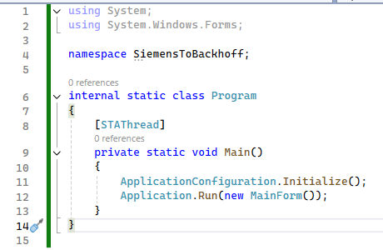

MainForm this class is responsible for handle User interface and backend business logic binding.
From this constructor it defined the UI parameter and calls the BuildUI method.
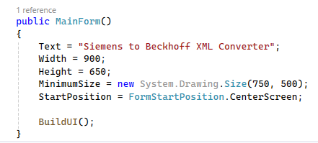
BuildUI: Creates a 5-row TableLayoutPanel (heading, input row, output row, action bar, log) and a bottom progress bar, wires button Click events. Called from: MainForm constructor.
UDT conversion tab (CreateTab / CreateFileRow): The same CreateTab helper builds both tabs. For the UDT tab it creates the input row, the output row and the Convert UDT / Batch Convert UDT Folder buttons, and wires their Click events to ConvertUdtFile and BatchConvertUdt.

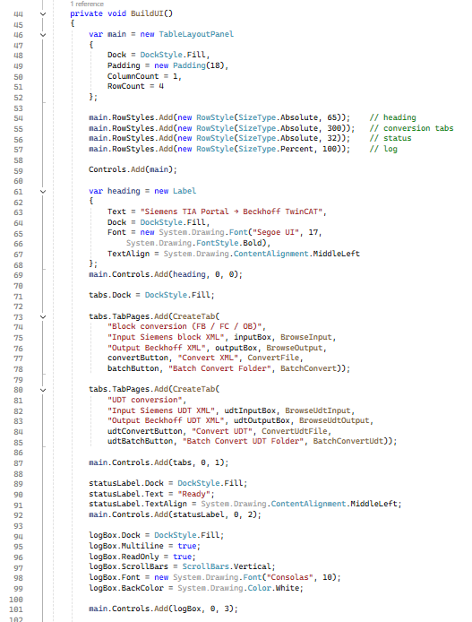
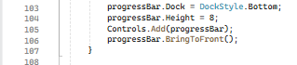
Output: All controls placed. Convert and Batch handlers attached.
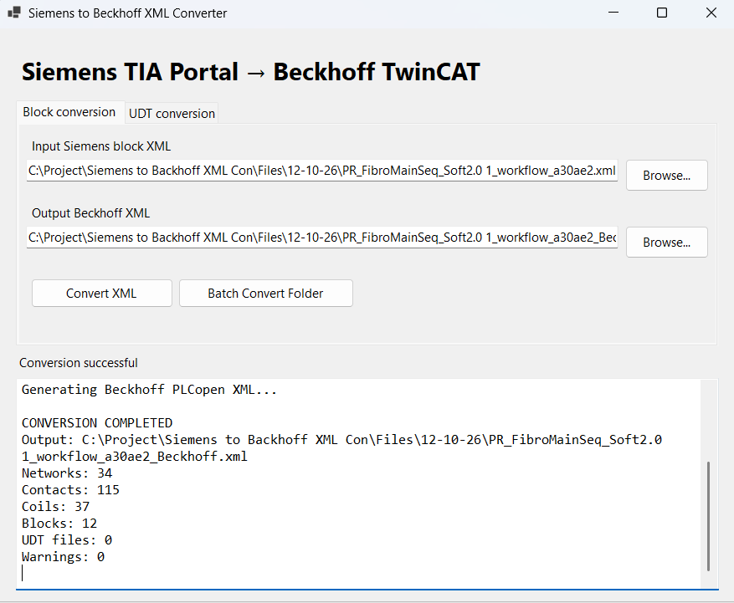
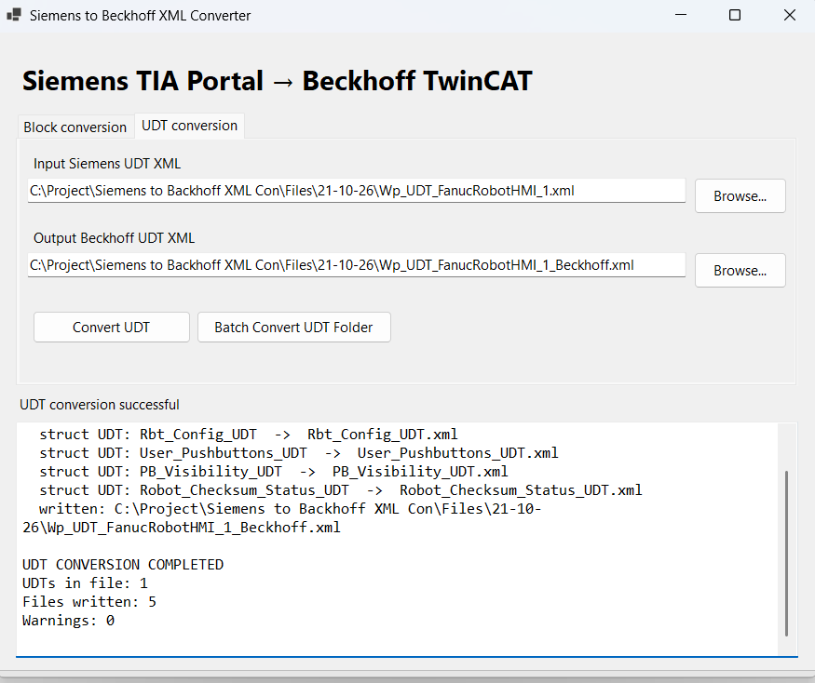
It calls: BrowseInput (For select input xml), BrowseOutput (For select output xml file)
ConvertFile: Validates input/output paths, calls SetBusy for freeze the UI, parses, generates, creates the output directory, writes UTF-8 (no BOM) file, logs counts and warnings, updates status and shows a result box. Exceptions are logged and shown.
Called from: Convert XML button. Output: Beckhoff XML file on disk; log text; message box.
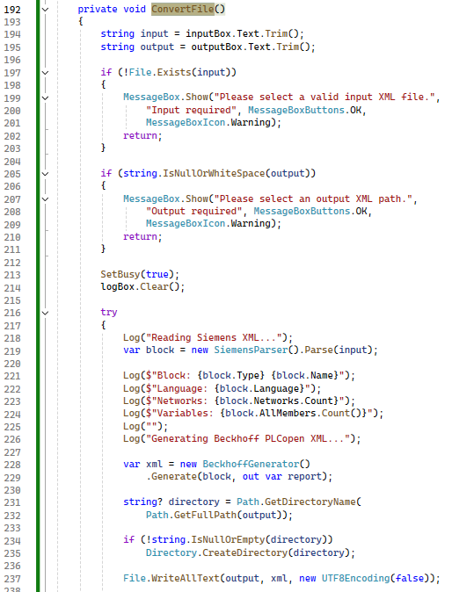
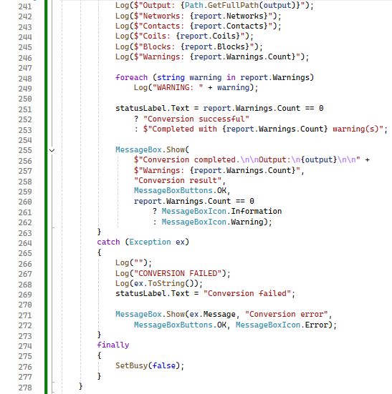
Parse: method (SiemensParser (SiemensParser.cs) class) is responsible for parse the Input XML file data, it checks file exists, loads XDocument, finds SW.Blocks.FB, reads Name, ProgrammingLanguage, Number, warns if not LAD,
This method calls ParseInterfac, loops CompileUnits calling ParseCompileUnit.
Called from: MainForm.ConvertFile / BatchConvert.
Output: SiemensBlock (interface + networks + warnings).

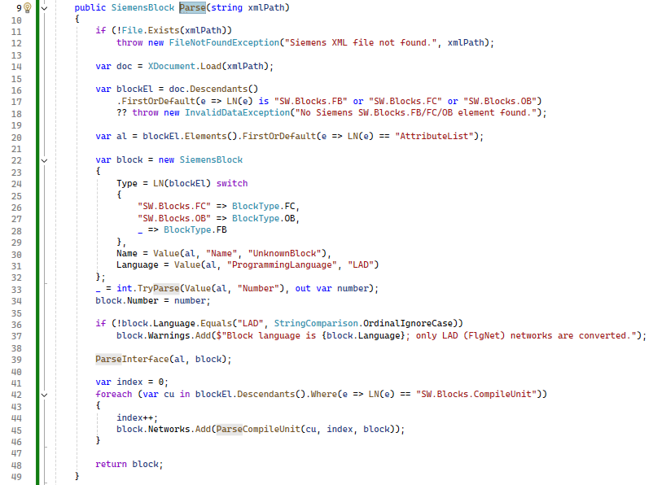
LN : Returns element LocalName so namespaces are ignored. Called from: Every parser method. Output: String.
Value : Finds a child by local name and returns trimmed text or fallback. Called from: Parse. Output: String.
ParseInterface: Finds Interface/Sections (or parses Interface text as XML/ Extract interface tag data), loops Section and Member elements, warns on nested members, creates Member objects. Called from: Parse.
Output: block.Sections filled (Input, Output, Static, …).
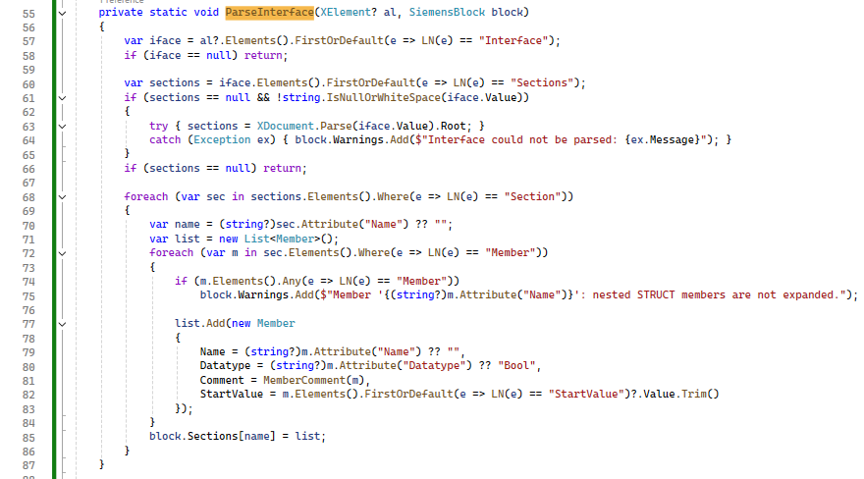
MemberComment: Selects en-US MultiLanguageText, else first non-empty.
Called from: ParseInterface. Output: Comment string.
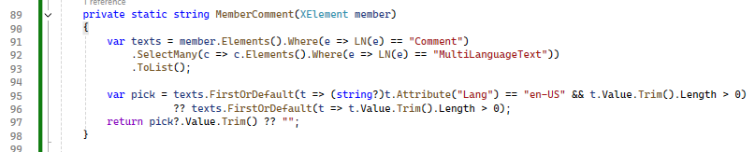
ParseCompileUnit: Using this method reads network Title and Comment, finds FlgNet, loops Parts (Access tags and mapping, Part with negated pins and instance), loops Wires (Powerrail, OpenCon, IdentCon, NameCon).
Called from: Parse (once per CompileUnit). Output: Network object.
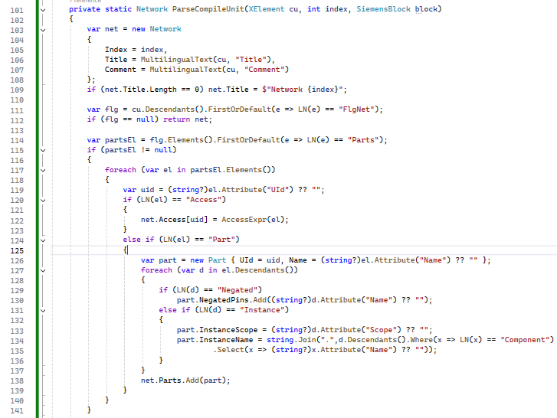
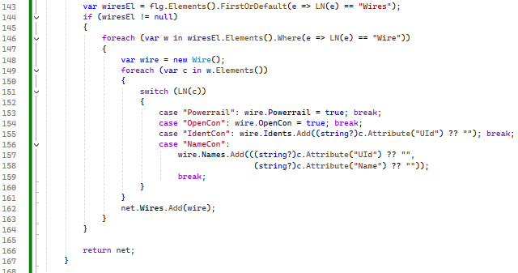
AccessExpr: Converts Access to text like literals, typed constants, strings, symbol components, array indexes (recursive).
Called from: ParseCompileUnit; itself for array indexes.
Output: Expression string (e.g. XYZ.Arr[1]).
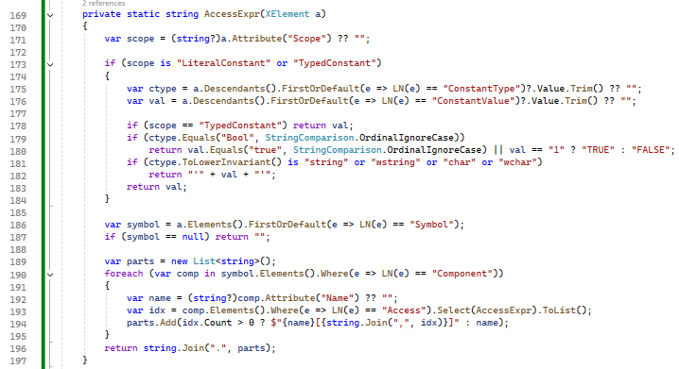

Map: This method is matches and map orders of Array, String, primitive dictionary, timer/counter, otherwise update derived name. Arrays recurse on the base type.
Called from: BeckhoffGenerator (AddGroup, BuildInterface, BuildPlainText).
Output: (Text, TypeSpec) tuple.
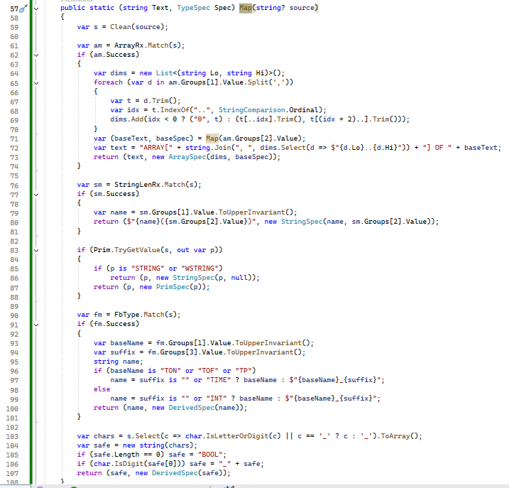
Generate : This method contains in BeckhoffGenerator (BeckhoffGenerator.cs) class, it is creates LdContext, timestamps and ObjectId, builds LD with left rail, converts every network, adds right rail, builds plain text and interface, assembles pou/project XDocument, fills ConversionReport, adds edge-bit warnings.
Called from: MainForm.ConvertFile / BatchConvert. Output: XML string and ConversionReport (out).
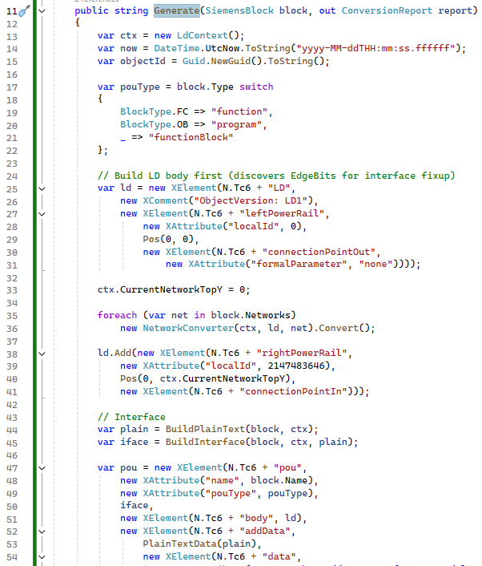
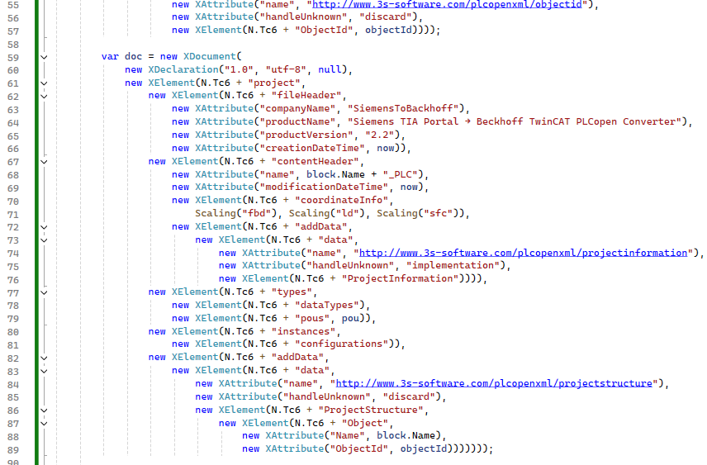
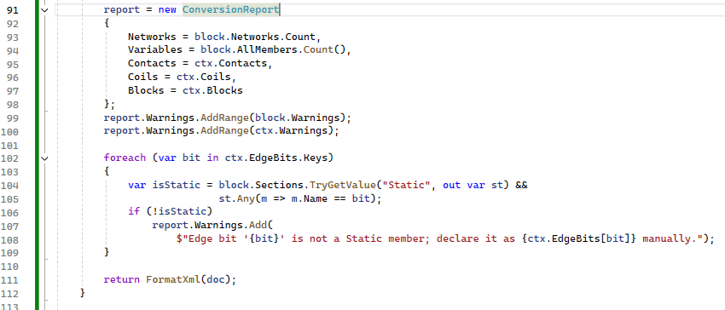
AddGroup: In this method contains loops members, overrides type with R_TRIG/F_TRIG for adds value.
Called from: BuildInterface (5 times).
Output: One variable group appended to the interface.
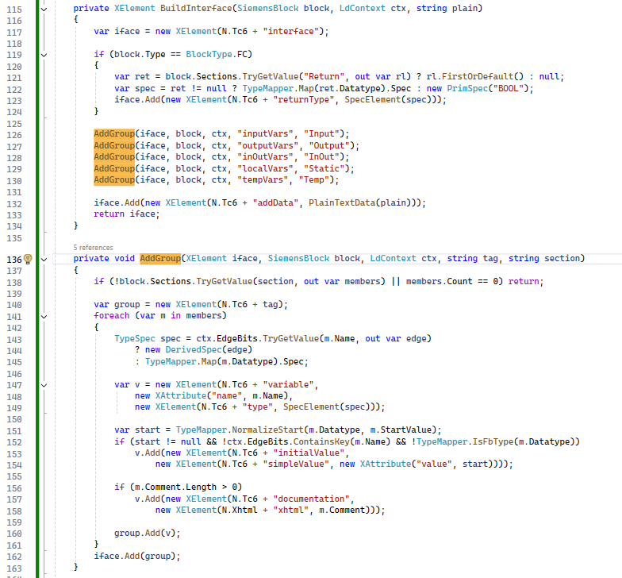
SpecElement : This is Switch on TypeSpec like prim, derived, string(length), array(dimension + baseType).
Called from: BuildInterface, AddGroup, itself (arrays). Output: XElement type node.
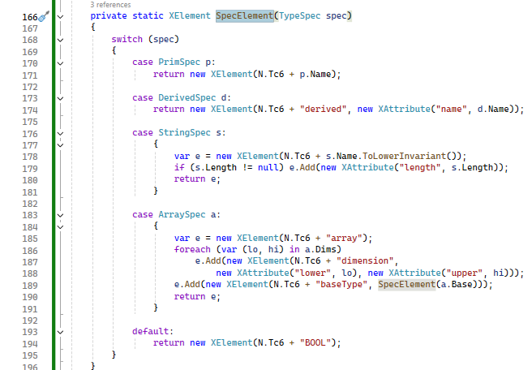
FormatXML : Saves XDocument with indentation, CRLF and UTF-8 settings. Called from: Generate (last step). Output: XML string.
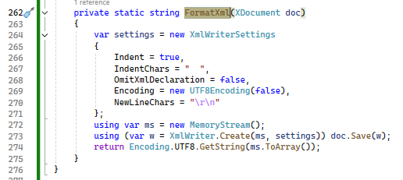
Convert: Indexes parts, call the BuildGraph, AddNetworkTitle methods, it returns parts in ExecutionOrder, ApplyLayout.
Called from: Generate (per network). Output: LD elements appended to the shared <LD>; positions set.
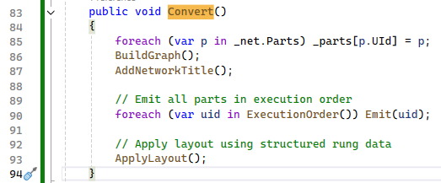
BuildGraph : Splits each wire into outputs/inputs, fills _pinNames, _destVar, _openOut and _sources.
Called from: Convert.
Output: Wire graph dictionaries.
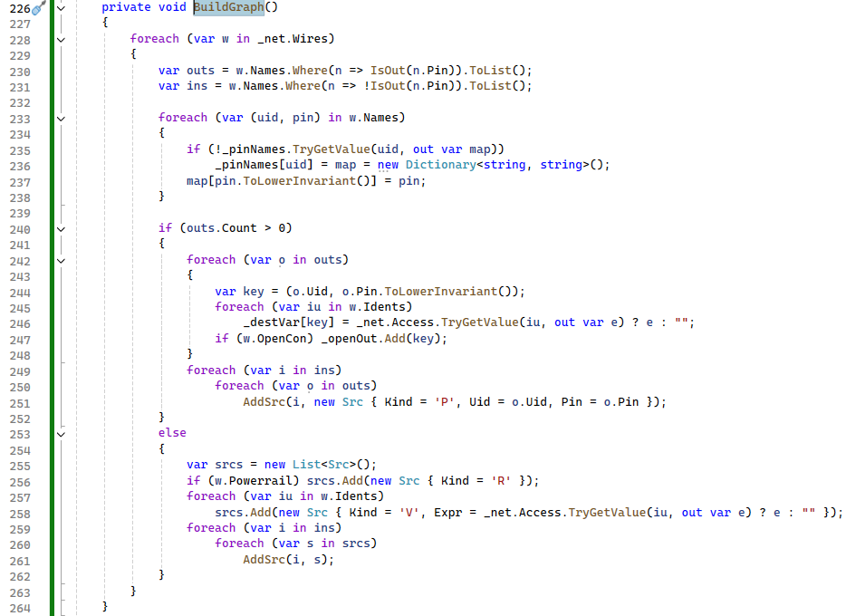
AddNetworkTitle: Builds a comment from Title/Comment and a 'networktitle' element.
Called from: Convert. Output: Two title elements; ids saved in _titleIds.
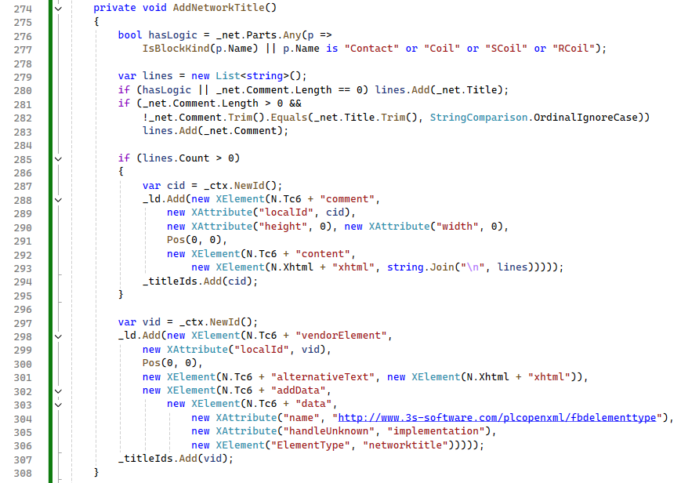
ExecutionOrder: Method extract data list of wires from power rail (contacts → coils → blocks like move etc.), then remaining parts.
Called from: Convert. Output: Ordered list of part UIds.
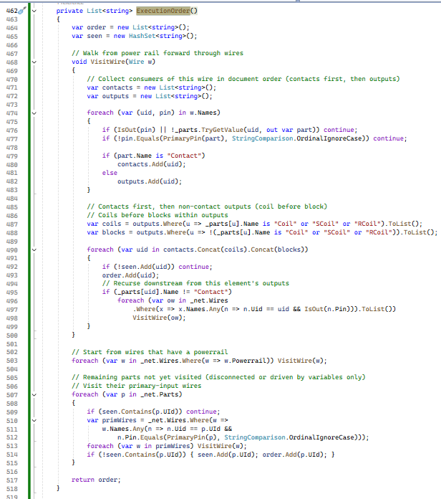
Emit: Using this method apply validation for repeat/recursion,
switches on part name: Contact, Coil/SCoil/RCoil, block (move etc.) kinds, or unsupported.
Called from: Convert. Output: <contact>, <coil>, <block> or UNSUPPORTED <comment>; _done[uid]=localId.

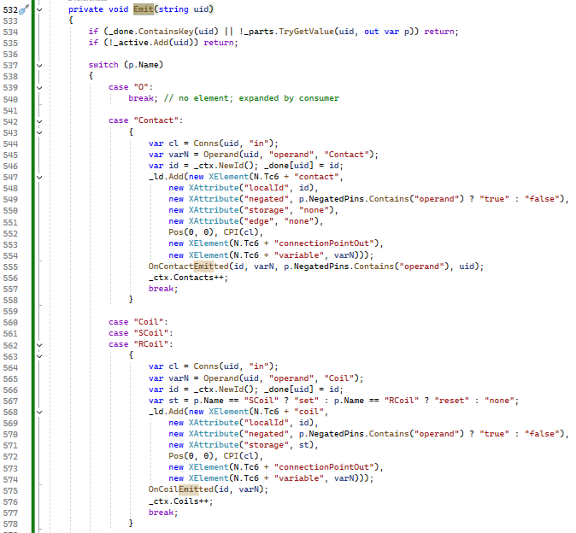
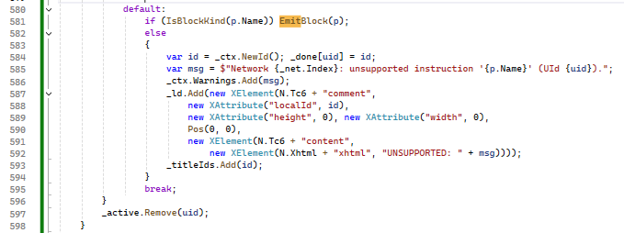

Operand : Returns first variable source of a pin; otherwise adds a warning and returns TRUE. Called from: Emit (contact/coil), EmitBlock (edge bit). Output: Operand expression.
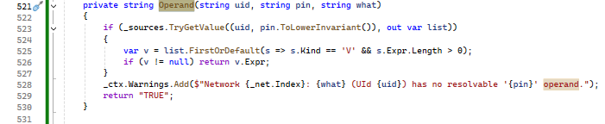

Conns : Resolves each source of an input pin into Conn(ref, formalParameter), creates inVariable, expands O parts, emits producers.
Called from: Emit, EmitBlock, OrConns. Output: De-duplicated list of Conn.
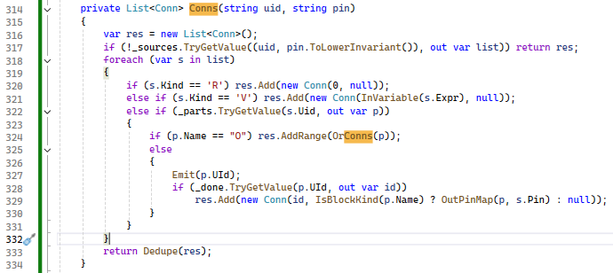

Dedupe : This method is Removes duplicate connections preserving order. Called from: Conns, OrConns. Output: Unique Conn list.
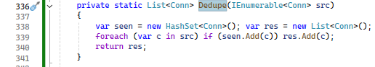

InVariable : This method Adds an <inVariable> with expression and records its id in _currentBlockInVars. Called from: Conns. Output: localId of the new element.
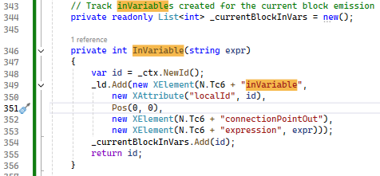

EmitBlock : Using this method resolves inputs, selects typeName/CallType/param types, sets instance names, builds inputVariables/outputVariables and addData, then reports to OnBlockEmitted. Called from: Emit. Output: <block> element; counters and warnings updated.
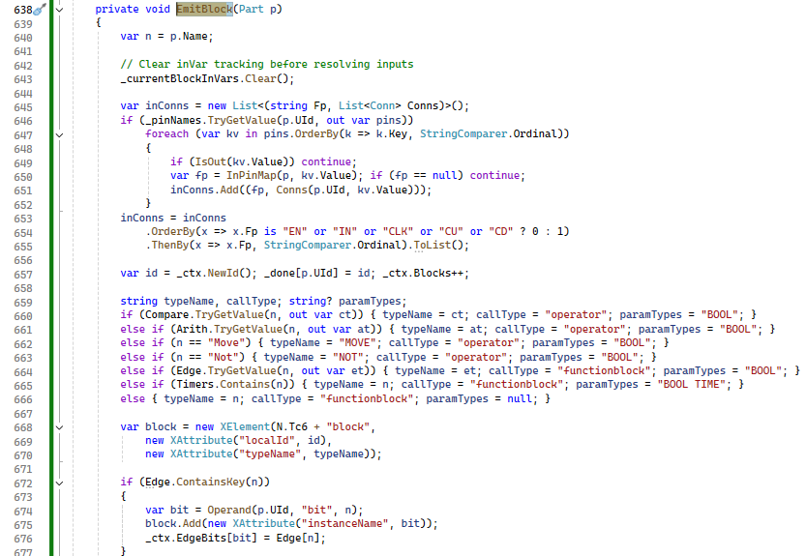
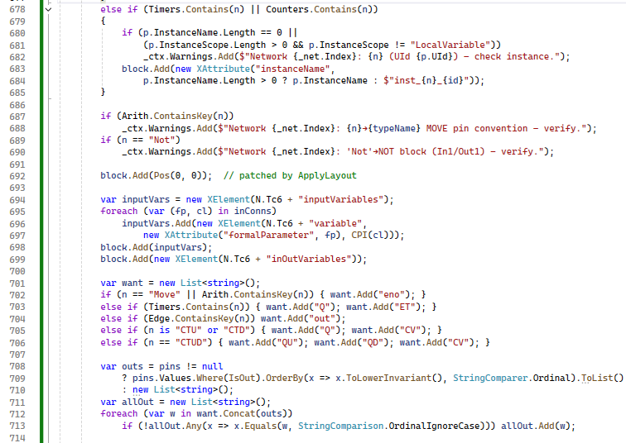
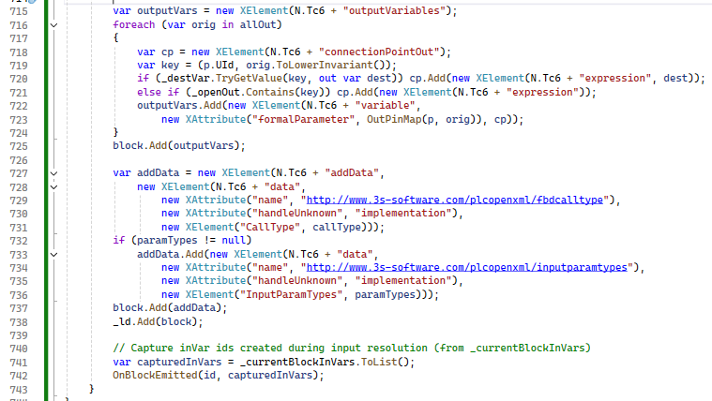

InPinMap : Translate Siemens pin names to TwinCAT formal parameters (EN, In1, Out1, ENO, CLK, Q).
Called from: EmitBlock; Conns (OutPinMap). Output: Formal parameter name.
OutPinMap : Translate Siemens pin names to TwinCAT formal parameters (EN, In1, Out1, ENO, CLK, Q).
Called from: EmitBlock; Conns (OutPinMap). Output: Formal parameter name.
PrimaryPin : Returns the main input pin of a part type.
Called from: ExecutionOrder, Chain. Output: Pin name.
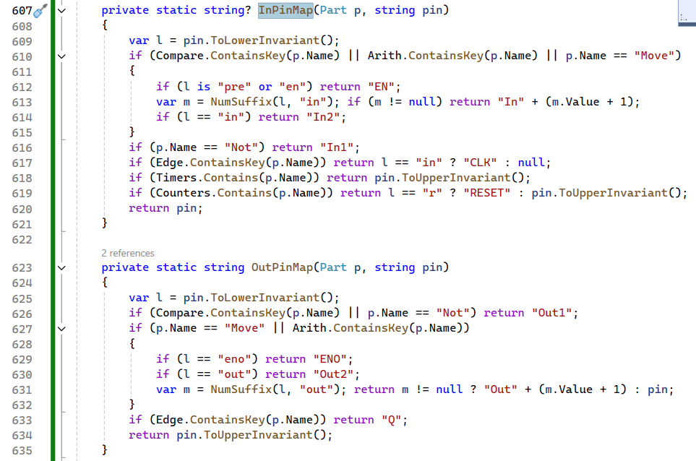
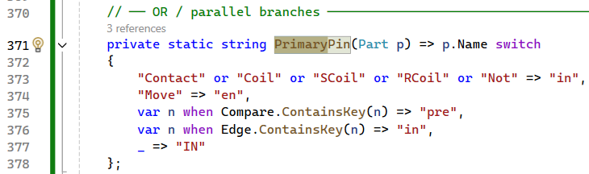

OrConns : This methods is responsible for handle OR connections, It collects in star pins of an O part, resolves each with Conns, merges and caches; calls AddParallelBranch if a block output is involved. Called from: Conns. Output: Merged connection list.
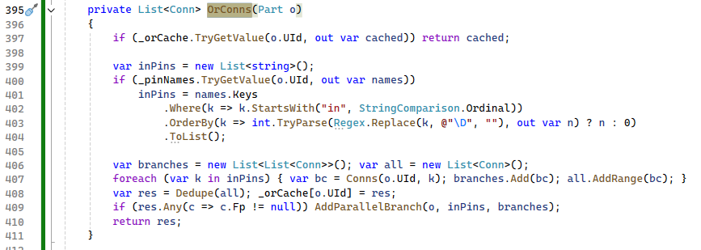

AddParallelBranch : Using this method finds common upstream element via Chain, writes ldparallelbranch vendorElement with BranchInput and Tree list.
Called from: OrConns. Output: Vendor element; id added to _titleIds.
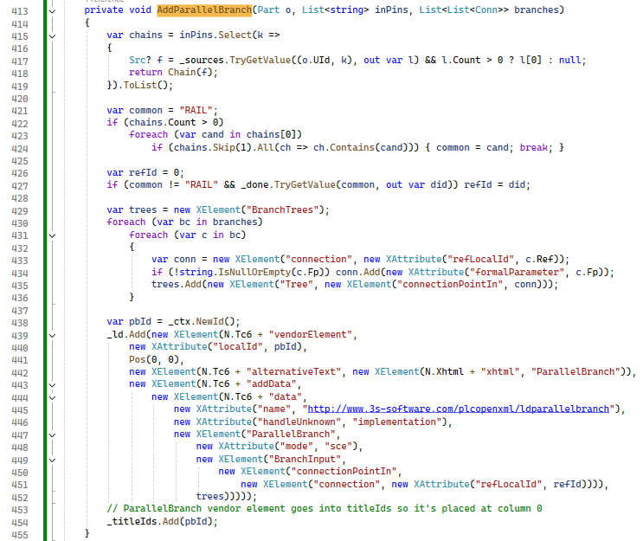

FindOrPartForContact: Scans wires for contact 'out' feeding an O part. Called from: OnContactEmitted. Output: O part UId or null.
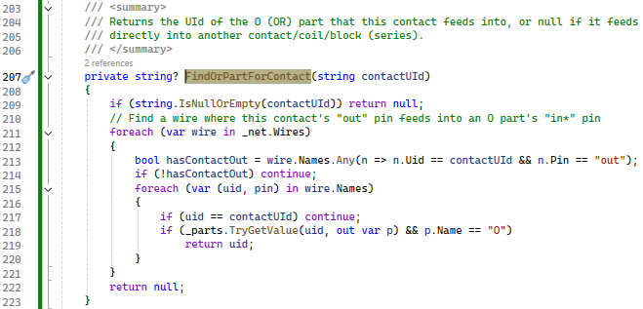
OnContactEmitted : Using this method Starts new rung after outputs, adds contact to OR group or own column.
Called from: Emit (Contact). Output: Rung.ContactGroups updated.
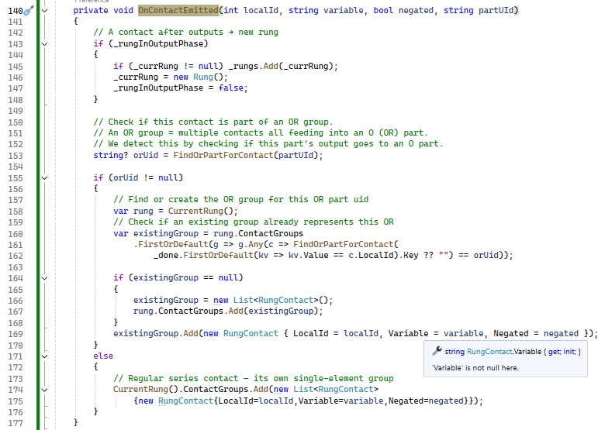
OnCoilEmitted: Inserts coil as Outputs arrays and sets output phase.
Called from: Emit (Coil). Output: Rung.Outputs updated.

OnBlockEmitted: It returns the value for series column before coil, parallel output after coil.
Called from: EmitBlock. Output: Rung updated.
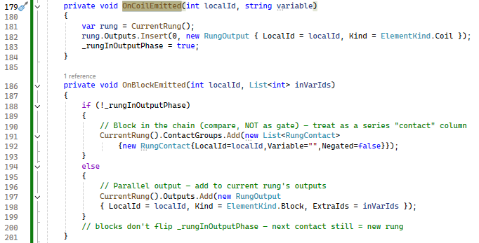

Compute: This method is present in LayoutEngine (LayoutEngine.cs). Using this method Places title ids at network top, then adds rungs from top and Title.
Called from: NetworkConverter.ApplyLayout. Output: Dictionary contains localId.

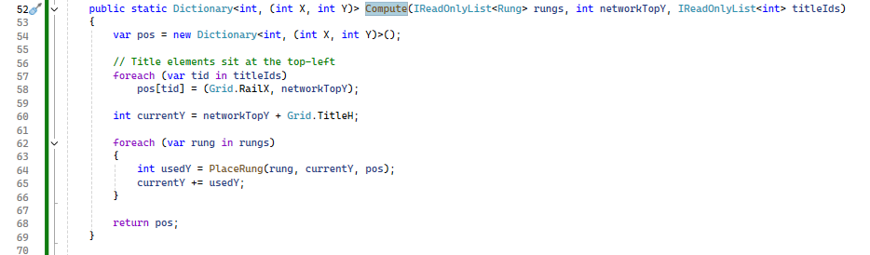

PlaceRung: Using this method computes OR row count, places contact columns at StartX + n·ContactW, then coil on main row and blocks on lower rows with their inVariables to the left. Called from: Compute (per rung). Output: Fills position map; returns consumed height in pixels.

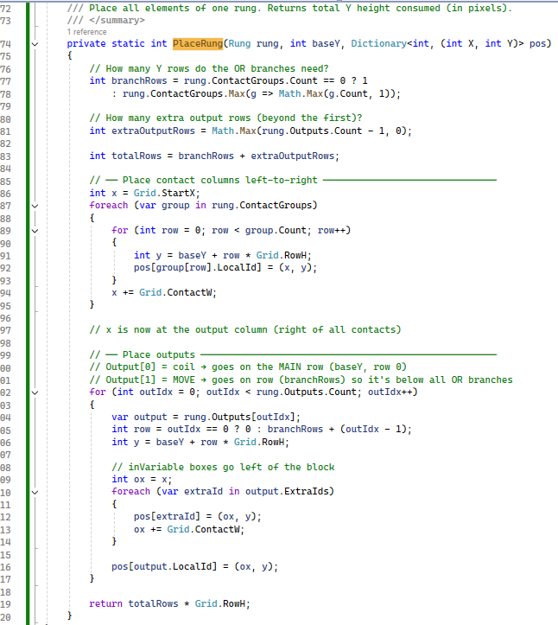

LdContext is a supporting class which is holds Warnings, EdgeBits, counters (Contacts, Coils, Blocks) and CurrentNetworkTopY across networks.
Called from: All converter classes; Generate reads it for the report. Output: Shared state.
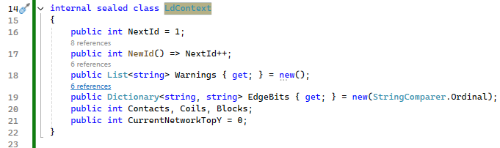

SiemensBlock.AllMembers: Using this sub method stores the value for Input xml parameters

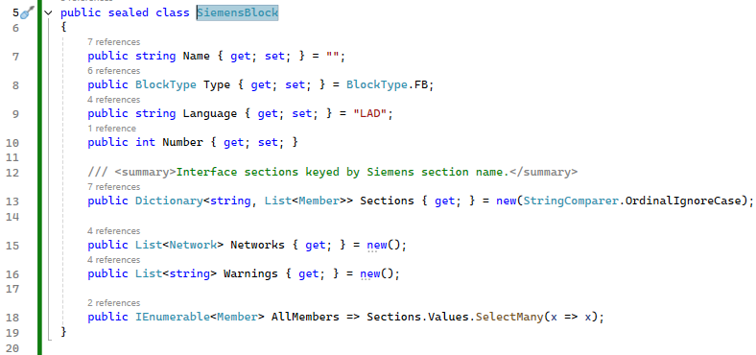

ConvertUdtFile: Validates the input and output paths, calls SetBusy, clears the log, calls SiemensParser.ParseUdts, creates the output folder and loops over the returned UDTs. With one UDT the main file uses the output path from the UI, otherwise <UdtName>_Beckhoff.xml. Each UDT is written with WriteUdt. It logs the UDT count, files written and warnings, updates the status label and shows a result box. InvalidDataException shows a hint to use the Block conversion tab; other exceptions are logged and shown.
Called from: Convert UDT button. Output: Beckhoff UDT XML files on disk; log text; message box.
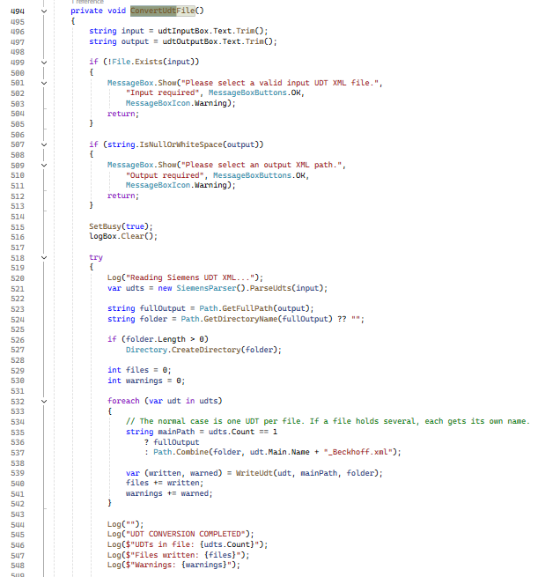
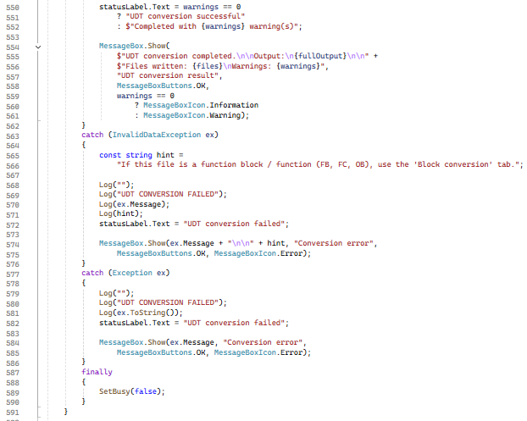

SiemensParser.ParseUdts: Checks the file exists, loads the XDocument and finds every SW.Types.PlcStruct (InvalidDataException if none). For each UDT it reads Name (made valid by StructExtractor.SafeName), calls FindSections and ParseMembers for every Section, reserves the UDT name in the registry with a member, then calls StructExtractor.Lift so Struct members become nested UDTs.
Called from: MainForm.ConvertUdtFile / BatchConvertUdt. Output: List<SiemensUdt> (Main UDT, Nested UDTs, Warnings).
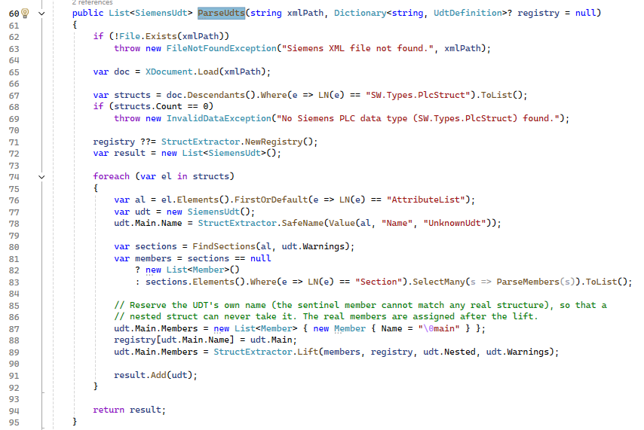

ParseMembers / ParseMember: Reads every Member of a Section. Each Member keeps Name, Datatype (default Bool), comment (MemberComment, en-US first), StartValue and Children, which are read recursively, so a Struct carries its own members.
Called from: ParseUdts, ParseInterface, itself for Struct children. Output: List<Member>.
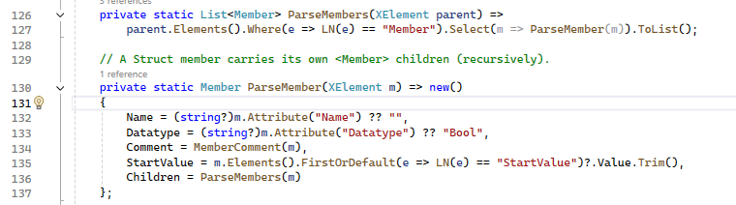

WriteUdt: Logs the UDT name and member count. For every nested UDT it calls UdtGenerator.ToFile and writes the file into the folder (logged as "struct UDT: name - file"), then writes UdtGenerator.Generate(Main) to the main path and logs the UDT warnings.
Called from: ConvertUdtFile, BatchConvertUdt. Output: Tuple (files written, warnings).
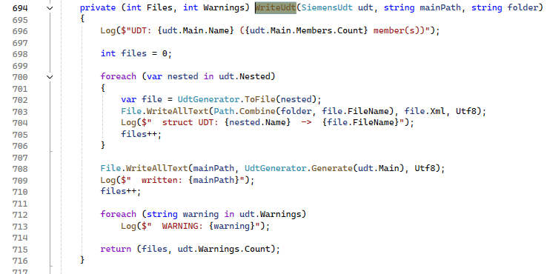
UdtDefinition / SiemensUdt / GeneratedFile: UdtDefinition holds the name and members of one Beckhoff data type. SiemensUdt holds Main, Nested, Warnings and All (Nested first, Main last). GeneratedFile is the (FileName, Xml) pair written next to the main output.
Called from: ParseUdts, StructExtractor, UdtGenerator, MainForm. Output: Data carried between parser, generator and UI.
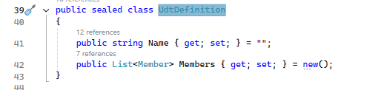
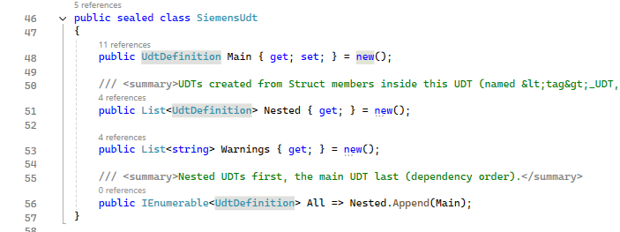
ExpandInRange : Using this method handle the InRange, it becomes Ge + Le; Inc / Dec become Add / Sub with a generated constant '1' (Network.Access entry uid_one).
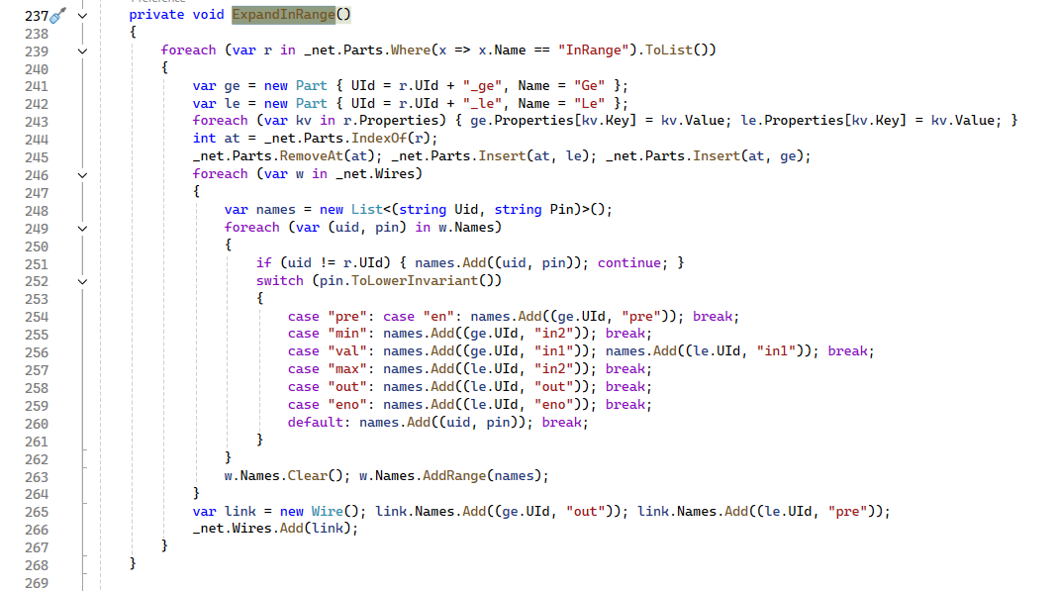
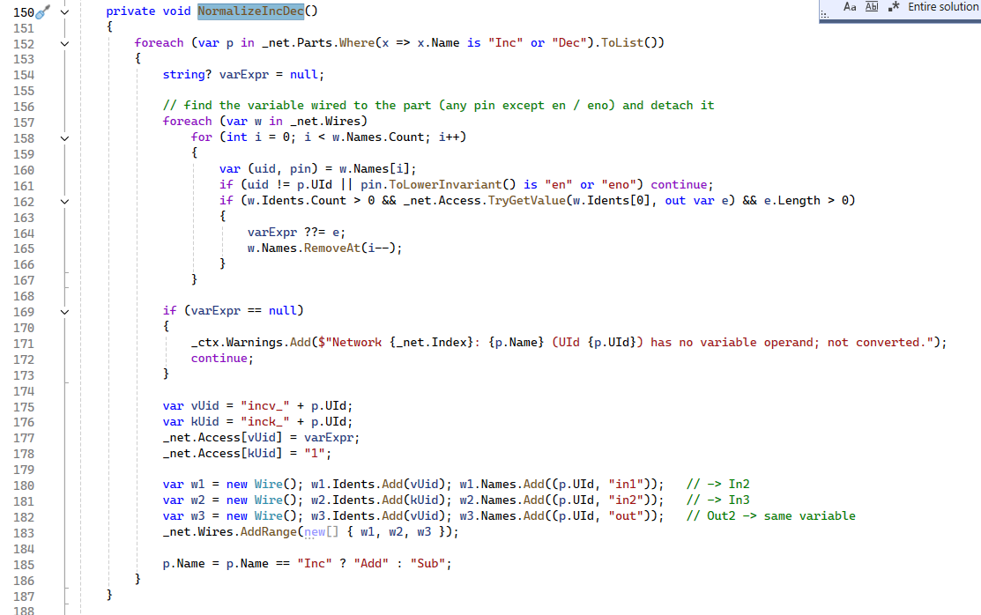

EmitFuncBlock: Using this method handle to writes MEMSET / MEMCPY / LEN function-call blocks (EN, arguments, ENO and return pin) and adds the warnings.
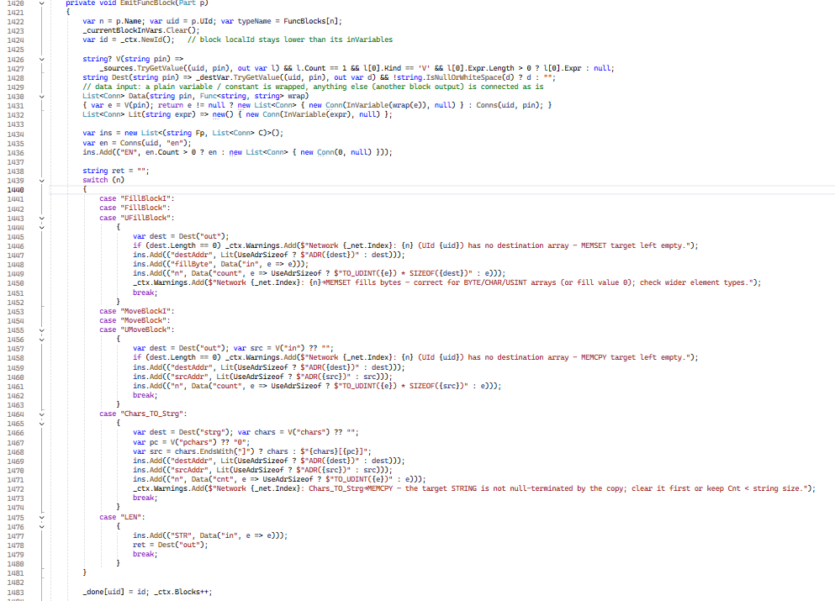
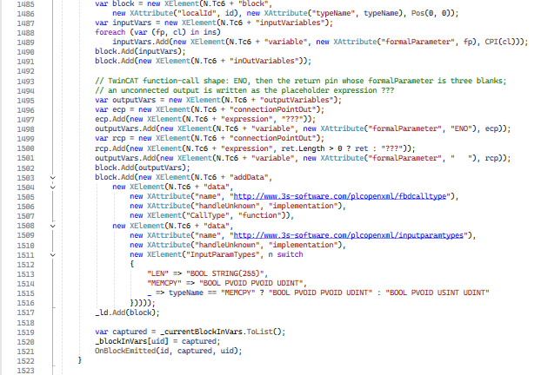
LdRungOrder.Reorder: Using this method handle the network component, orders the XML elements of a network rung by rung (first connection, then ParallelBranch, then remaining references).
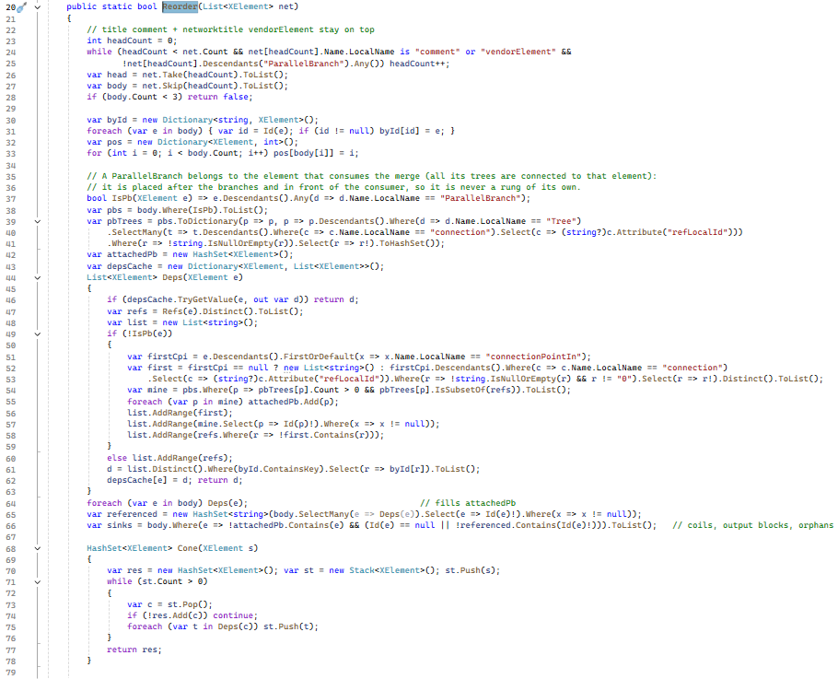
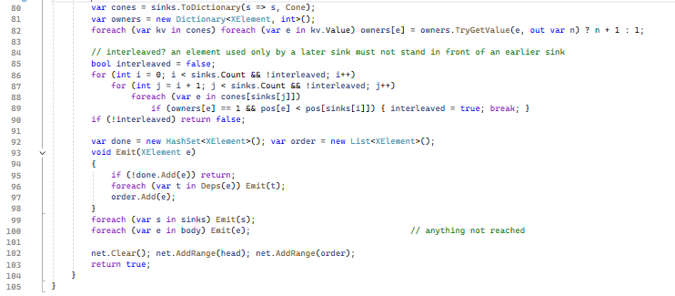

ParseCompileUnit : In this method update the code for handle the import error occurs due to block calling, for this implement the logic to avoid the block calling network from conversion and add the infor in generated report.

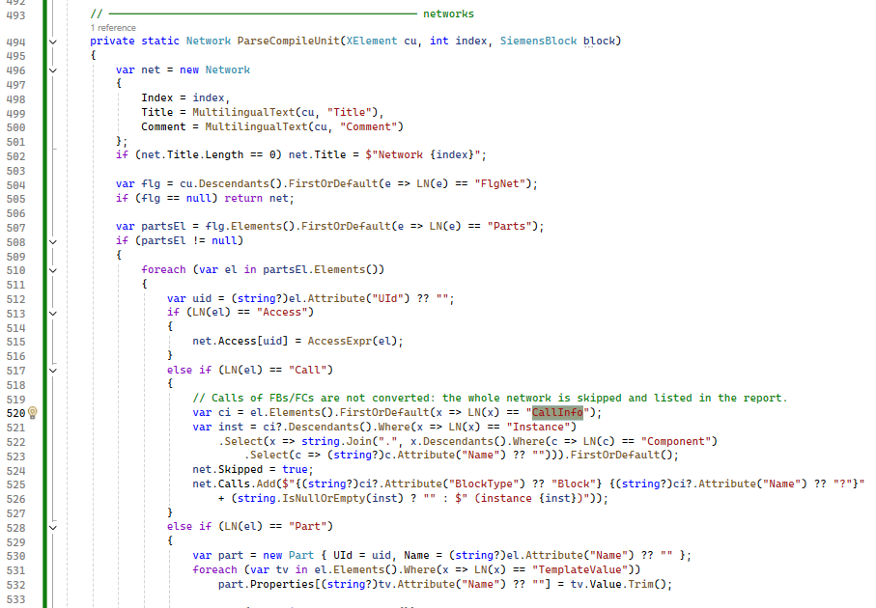
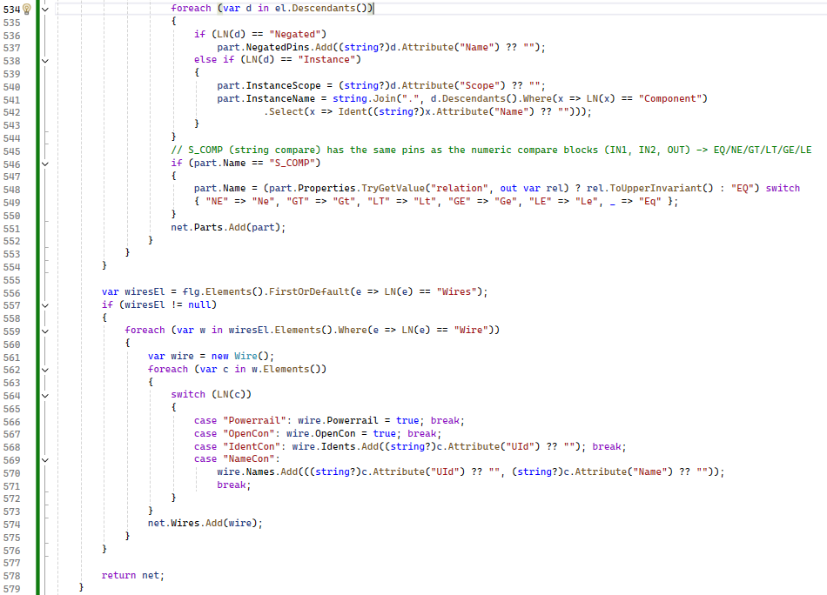

Conversion report (.txt)
Location: <exe folder>\Report\ (created if missing). File name: <input xml name>_Report_<yyyyMMdd_HHmmss>.txt, so every conversion creates its own file; batch conversion writes one report per input file. The log shows 'Report: <path>'.
Content:
- Header: block type and name, date / time, counts (networks, variables, contacts, coils, blocks, UDT files).
- 1. Tag name changes: Siemens name -> Beckhoff name.
- 2. Data type changes: types that differ after conversion like Struct members created a UDT file.
- 3. Networks that need HUMAN IN LOOP review (network number, title, reasons).
- 4. Summary: network numbers that need review, skipped networks and networks converted directly; general notes.
A network is flagged HUMAN IN LOOP when it has:
- a block call (timer, counter, edge block, function MEMSET / MEMCPY / LEN, Convert, instance) - it is converted but must be checked;
- a FB / FC call (CallInfo) - NOT CONVERTED, the network must be built manually;
- an OR merge with more than 3 parallel branches (Card > 3);
- an instruction that was replaced by an equivalent (Inc/Dec, InRange, PBox/NBox, FillBlockI, MoveBlockI, Chars_TO_Strg);
- an unknown instruction, an element added by the converter (for example a TRUE contact) or any other converter warning of that network.
Networks without any of these are listed as 'converted directly'.

